Speed meeting for slow art projects…
Networking for creativity in Roscommon 3-5pm, November 17, 2021.
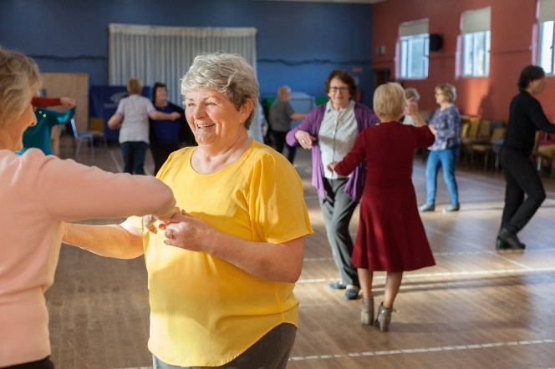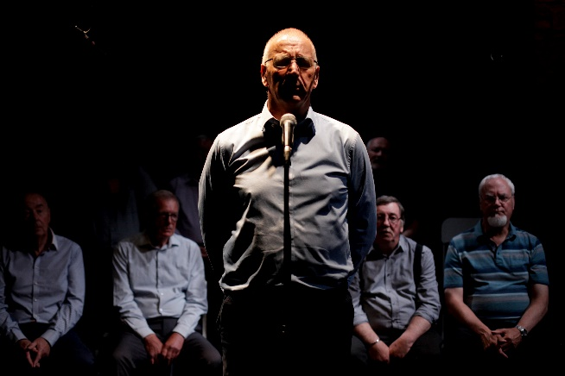

Calling all Older People Organisations in Roscommon
- Are you part of a group that organises Bealtaine Festival events each May or an organisation that works with older people?
- Would you or the people you work with like to get involved in creative projects more generally?
- Would you or the people you work with like to work with a professional artist (musician, dancer, sculptor, poet etc.) on an event or project that is new, exciting, challenging or close to your heart?
Age & Opportunity’s Bealtaine Festival with Roscommon Arts Office wish to facilitate a (virtual) meeting between older person organisations and local artists, to chat about creative ideas and see if there is potential to work together in the future. If you would like to attend, please complete the application form below.
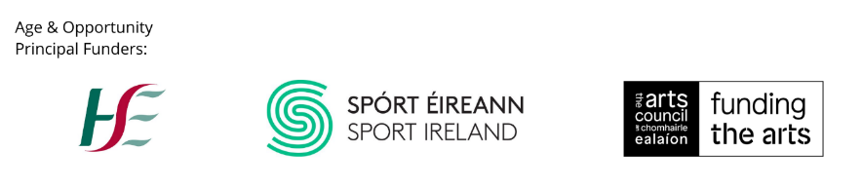
Networking for Creativity - Application Form for Organisations
If you represent an older persons’ organisation and would like to attend this creative networking meeting on Wednesday 17th November (3-5pm), please fill out the details below and return to artsofficer@roscommoncoco.ie by November 5th. Places are limited.
Name of group/organisation:
Name of main contact:
Email:
Phone number:
Which of these best describes your organization?

Community Hospital ☐ Day Care Centre ☐ Nursing Home ☐

Active Retired Group ☐ Community Interest Group ☐ Mens’ Shed ☐
Local Arts Group ☐ Day Centre ☐ Residential Centre ☐
Other – please specify below

Please complete the questions below and tick this box to confirm you would like to share the information with the selected artists. ☐

What your organisation does (1-2 lines):

A little about the people you work with (1-2 lines):

How many people do you work with:

Where you are in the county:

What artforms are of interest:

Please note that all information provided will be shared by Roscommon Arts Office with Age & Opportunity for the purposes of organising this event.

