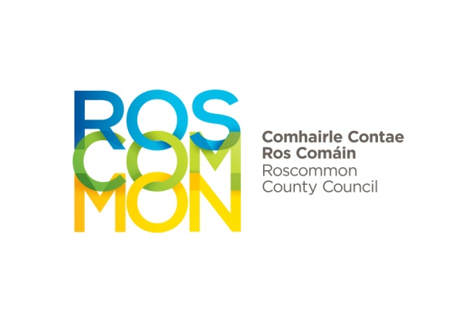

CLÁR Programme 2020

The Department of Rural and Community Development announced details of the CLÁR programme for 2020 on 25th May 2020 which includes new measures to support rural communities. CLÁR provides funding for small scale infrastructural projects in rural areas that have suffered significant levels of population decline. The supports provided through CLÁR have been tailored this year to help rural communities to respond to the new COVID-19 environment. This includes the addition of new funding measures.

There is a national allocation of €5million for 2020 under 3 measures to be operated via Local Authorities and the Department of Rural and Community Development for a range of School and Community projects.

Measure 1: Support for Schools/Community Safety Measures
Measure 2: Community Recreation Areas
Measure 3: Community Wellbeing Support, comprising:
- Meals on Wheels and linked services
- Mobility and Cancer Care Transport

Up to 10 applications in total will be invited from relevant Local Authorities in respect of Measures 1 and 2.

Measures 3 will be operated directly by the Department of Rural and Community Development.

In order to facilitate schools/communities in preparing an application full details of the scheme and application forms are available on www.roscommoncoco.ie

Closing date for receipt of fully completed Application Forms for Measures 1 and 2
by email only to khegarty@roscommoncoco.ie is 5pm on Friday, 17th July 2020
Late submissions will not be considered.

Majella Hunt  Director of Services  Tourism, Community & Enterprise, Special Projects & Regeneration, Arts & Libraries  Roscommon County Council  Áras an Chontae  Roscommon  F42 VR98 | 

