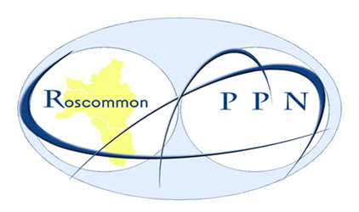

ROSCOMMON
PUBLIC PARTICIPATION NETWORK

CONSTITUTION

Contents

PAGE

- INTRODUCTION 3

- ROSCOMMON PPN OBJECTIVES 3

- ROSCOMMON PPN VALUES & PRINCIPLES 4

- ROSCOMMON PPN STRUCTURE 5
- Membership
- A County Plenary
- The Elected Secretariat & Resource Worker
- Three Municipal District (MD) Plenaries
- Linkage/Special Interest Groups
- Policy Making Bodies/ Committees

- ELECTION OF REPRESENTATIVES TO COMMITTEES 11
- Nominations Procedure
- Voting Procedure [Meeting & Postal]

- AMENDMENTS TO THE CONSTITUTION 13

- APPENDICES 14
Appendix 1 – Roscommon PPN Code of Conduct/Conflict of Interest Protocol
Appendix 2 – Roscommon PPN Representative Charter/Reporting Template
1. INTRODUCTIONS
The Roscommon Public Participation Network (PPN) was established as part of the Local Government Reform Act 2014. It is the main link through which Local Authority connects with the Community and Voluntary, Social Inclusion and Environmental groups in County Roscommon. Roscommon PPN aims to enable community organisations to articulate a diverse range of views and interests within local government system, and to allow a diversity of voices and interests to be facilitated and involved in the decision-making process of Roscommon County Council and other relevant bodies.
Roscommon PPN will:
- Facilitate the participation and representation of communities in a fair, equitable and transparent manner through the environmental, social inclusion & community and voluntary sectors on decision making bodies, including the new Local Community Development Committees (LCDCs)
- Strengthen the capacity of communities and of environmental, social inclusion and community and voluntary groups to contribute positively to the community in which they reside/participate
- Provide information relevant to the environmental, social inclusion and community & voluntary sector and act as a channel for information flow between the community and local authority.

2. ROSCOMMON PPN OBJECTIVES
Roscommon PPN will:
- Contribute to the local authority's development of the County of Roscommon and support in the development of a vision for the well-being of current and future generations.
- Be non-political, not showing favour or bias to any groups.

- Facilitate opportunities for networking, communication and the sharing of information between the community and voluntary sector and between the sector and the local authority and other relevant bodies.
- Identify issues of collective concern to the network and work to influence policy locally in relation to these issues.
- Actively support the inclusion in the network of potentially socially excluded groups, communities experiencing high levels of poverty, communities experiencing discrimination, including Travellers, to enable them to participate at local and County level and to clearly demonstrate same.
- Encourage and enable community participation in local decision-making structures and planning of services.
- Facilitate the selection of representatives from the environmental, social inclusion and community and voluntary sectors onto county decision making bodies.
- Support a process that will feed the broad range of ideas, experience, suggestions and proposals of the network into policies and plans being developed by agencies and decision makers in areas that are of interest and relevant to the Network.
- Work to develop the network and its member groups so that the work of the Network is clearly recognised, acknowledged and understood by local government and the Network has a strong community voice within the County.
- Ensure that clear and transparent mechanisms for the election of members of the local community onto decision making bodies are in place and upheld thus facilitating fair participation in policy making fora.
- Support individual members of the Network to develop their capacity and do their work more effectively.

3. ROSCOMMON PPN VALUES AND PRINCIPLES
Roscommon PPN will adhere to the following values and principles and will be:
- Inclusive of all volunteer led organisations in the county of Roscommon and actively seek the inclusion of groups that may traditionally be marginalised.
- Participatory, open, welcoming, respectful, collaborative and facilitatory; Roscommon PPN will encourage participation by members in all aspects of its operation and clearly communicate using a variety of traditional and new mechanisms.
- Independent from the Local Authority and of any other vested interests.
- Value Diversity and recognise that the Environmental, Social Inclusion, Community and Voluntary sectors are broad and made up of people with many different opinions.
- Transparent and open in our processes, procedures, dealings with member groups, representatives, Local Authority etc.
- Accountable to member groups, via implementing and abiding by good governance structures, policies and procedures

4. ROSCOMMON PPN STRUCTURE
Roscommon PPN operates a flat structure as the diagram demonstrates. This means that all groups in the PPN have an equal voice and an equal input to decision making.
It is a collective accommodating of a wide range of diverse views and perspectives.
It supports each member to develop new skills and contribute in an equal way to the organisation.
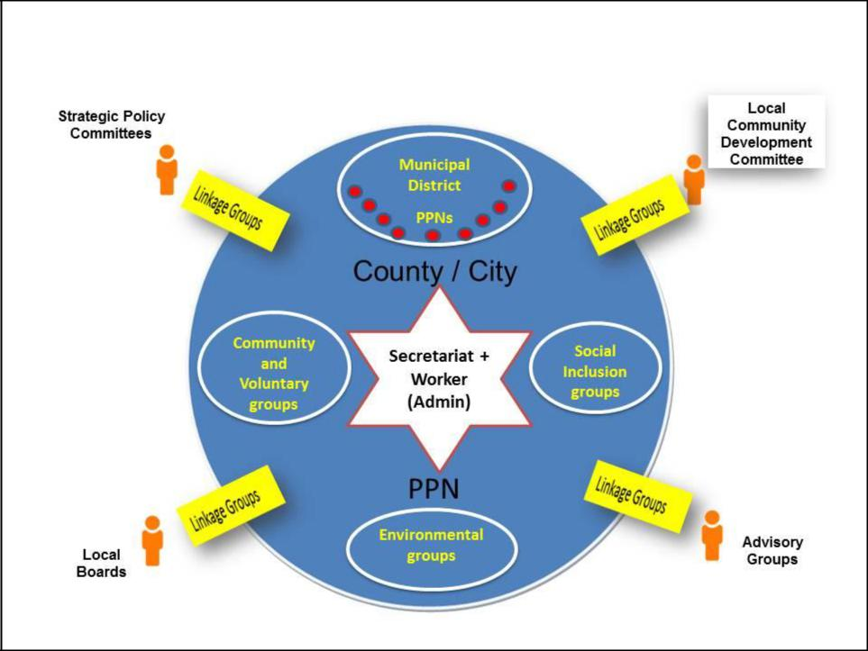

Roscommon PPN is organised at County level and at Municipal District level and comprises:
- Membership [Environment, Social Inclusion and Community & Voluntary Groups]
- A County Plenary
- Three Municipal District (MD) Plenaries
- The elected Secretariat & Resource Worker
- Linkage/Special Interest Groups
- Policy Making Bodies/ Committees

Membership
When joining the PPN, member groups must opt to be part of one of three electoral colleges namely Environment, Social Inclusion or Community & Voluntary. Organisations whose primary objectives are other than those listed above, will be members of the Community & Voluntary Electoral College. Each college chooses two people to represent them on the PPN Secretariat.
Each college elects members from among their own college members to represent them on the County’s Local Community Development Committee (LCDC) [see Section 4 Election of Representatives to Committees]
To become a member groups must fulfil the following criteria:
- Be active and with a postal address in the county.
- Operate on a not-for profit basis.
- Be volunteer led (organisations may have paid staff but must be under voluntary control).
- Be independent i.e. not a subcommittee or sub group of another organisation.
- Have at least 5 members and be open to new members.
- Have an appropriate governance structure e.g. a constitution / set of rules / financial procedures.
- Meet regularly.
- Have been in existence for at least six months.
- Be non-political.
- All members will adhere to Roscommon PPN Code of Conduct/Conflict of Interest Protocol [Appendix 1].

County Plenary
The County Plenary is the ruling body and main decision-making body of Roscommon PPN and will consist of all the membership groups.
- Its role is to direct the operation of the PPN, setting overall PPN policy and processes and develop a wellbeing statement for current and future generations in County Roscommon

- To delegate the day to day running of the PPN to the Secretariat
- To meet at least twice every year to review the workings of the PPN and set the agenda for the coming period
- Each member group may select two people to represent them on the County Plenary
- To give
- 21 days’ notice of the Plenary meeting is given to members.

- The quorum for a Plenary shall be 5% of membership groups
- Each member organisation will have one vote at the County Plenary

- A special meeting of the Plenary can be called if requested by two thirds of groups by petition of members

- The Plenary hosts elections of PPN members to the Secretariat, LCDC and other decision-making structures and committees [See Policy Making Bodies/Committees].
- Plenary meetings are a forum for member groups to meet and network and to hear about matters of interest to them.
- Decisions made between plenary meetings, including the election of representatives, must be presented for ratification to the following meeting.
- A special meeting of the Plenary can be called if requested by two thirds of membership groups by petition of members.
- A record of attendance will be kept for all meetings and a report generated.

- Plenary meetings will be facilitated by a person nominated to this role by the Secretariat.

Three Municipal District (MD) Plenaries
Roscommon County is organised into three Municipal Districts (Roscommon, Athlone & Boyle).
- Each Municipal District has a Public Participation Network [PPN] which deal with locally based matters and the MD Representative will report annually to the County Plenary on their activities

- Municipal District Plenary meetings are called by the Secretariat representative for each district annually
- Each member organisation may select two people to represent them on the Plenary of the Municipal District PPN
- Each member organisation will have one vote at the plenary
- The Municipal District will be guided by the vision and the objectives of the PPN
- Member organisations of the Municipal District PPN may also be a member of the County Plenary
- A special meeting of the Municipal District Plenary can be called if requested by two thirds of its membership by petition
- The Municipal District Plenary can develop and submit policy proposals as agreed by their membership

Linkage Groups/Special Interests Groups
Linkage Groups are the way that Roscommon PPN members have input into policy in their area of operation.
They operate by bringing together member organisations with a common interest to discuss their diverse views and interests in a specific policy area.
All PPN members groups have the option of joining one or more Linkage/Special Interest Groups.
All Linkage/Special Interest groups link with a specific Policy Making Body/Committee where there is a PPN Representative [see Policy Making Bodies/Committees] and operate as a reference group for the representative.
Linkage/Special Interest groups will communicate in a variety of ways including face to face & electronically.
Roscommon PPN have developed a Representative Charter to which all Representatives are required to adhere. [Appendix 1 Representative Charter]
Linkage/Special Interest groups operate as follows:
- Discuss and debate issues of relevance to the committee/specific policy area.
- Seek nominations and elect PPN representatives onto Policy Making Bodies/Committees [see Policy Making Bodies/Committees]
- Engage in two-way communication with their elected representatives. Representatives feedback to the Linkage/Special Interest Group and is accountable to them.
- Can censure or remove a representative if two thirds of the Linkage/Special Interest Group members agree that they are not fulfilling the terms of the representatives’ charter. If a representative is not fulfilling the terms of the representative charter this shall be reported to the Secretariat. Representatives will be guided by the Representative Charter
- Encourage new members participation
- Can develop and submit policy proposals as agreed by their membership

The elected Secretariat and Resource Worker

The Secretariat is at county level and is broad and representative of the different geographical areas and the three electoral colleges [Environment, Social Inclusion or Community & Voluntary] within County Roscommon and reflective of the diversity of the membership.
Roscommon PPN Secretariat is made up of 9 members; 2 from each the electoral colleges (Environmental, Social Inclusion, Community and Voluntary) and one representative from each of the three Municipal Districts (Roscommon, Athlone & Boyle)
The Secretariat is the administrative body and is delegated responsibility for the day to day running of the PPN. It meets a minimum of 4 times annually, its role includes the following:

- Facilitate the implementation of the decisions of the Plenary
- Ensure the proper functioning of the PPN in between plenaries.
- Coordinate the activities of PPN
- Communicate extensively and regularly with all PPN members and in this process share information concerning all PPN activities as widely as possible

- Act as a point of contact for the PPN in relation to the LA, DECLG, other PPN’s and all third parties
- Handle all correspondence on behalf of PPN, through distributing copies and drafting agreed responses
- Maintain accurate records of PPN business (hard and soft copies), including minuting meetings and circulating agendas
- Ensure that the finances of the PPN are properly managed and in a transparent manner
- Elections to the Secretariat will take place at least once every five years and can be initiated by the Secretariat or by a meeting of the Plenary.
- Manage the PPN Resource Worker.
- The PPN Resource Worker is responsible for the day-to-day activities of the PPN and for enabling the delivery of the aims and purpose of the PPN in line with the agreed workplan

Policy Making Bodies/Committees
Roscommon County Council and other local bodies have a range of Policy Making Bodies, Committees and Boards to support them in their work and policy development.
In County Roscommon these decision-making bodies include;
- Local Community & Development Committee [LCDC]
- As per LCDC regulations it is prescribed that a minimum of 2 persons representing Community and Voluntary interests, a minimum of 2 persons representing Social Inclusion interests and a minimum of 1 person representing Environmental interests be included on the Committee.
- Joint Policing Committee
- Four Strategic Policy Committees
- Planning
- Economic Development & Enterprise Support [including Roads & Culture]
- Environmental & Emergency Services
- Housing & Corporate
- Roscommon County Childcare Committee
- Roscommon Heritage Forum
- Evaluation Committee
- Western Region Drug and Alcohol Task Force [WRDATF]

Other committees may require community representation in the future.
Roscommon PPN have representation on these bodies/committees and when Roscommon County Council and other relevant local bodies seeks representative(s) they contact the PPN secretariat with the details [See Section 5 Election of Representatives to Committees].
Each of these committees have their own Terms of Reference and PPN representatives should familiarise themselves with these.

- ELECTION OF REPRESENTATIVES TO COMMITTEES
The representation of Environmental, Social Inclusion, Community and Voluntary voices on decision making and advisory bodies is a core function of PPNs [Section 4 Linkage/Special Interest Groups].
Having PPN representation on these committees is a huge advantage as it enables the concerns and experiences of the community to be incorporated at an early stage of policy development, leading to more positive outcomes. It also supports the monitoring and evaluation of existing policies within the county.
To be eligible for election as a representative of Roscommon PPN an individual must
- Be nominated by their member organisation
- Be committed to the aims, objectives and principles of Roscommon PPN
- Attend meetings of the relevant body that he/she is to sit on
- Articulate, discuss and negotiate on behalf of Roscommon PPN
- Be contactable by member organisations
- Report back issues of relevance to Roscommon PPN members (using Representatives Reporting Template provided – see Appendix 2]
- Advise Roscommon PPN of issues which require a response, formulation of policy or other action.
- Receive instructions from Roscommon Public Participation Network through a linkage/special interest group on matters to bring forward to the relevant body that he/she is to sit on.
No community representative may sit on more than one committee in addition to the Secretariat
The election of representatives is three years in length and involves Roscommon PPN carrying out a nomination and voting procedure as outlines above. The initial Secretariat group, due to the formation of the Roscommon PPN may sit for longer than three years. The first round of elections to be held in June 2019 will include three of the original members stepping down. Thereafter an additional three members of the original group will stand down in 2020 and so on after three years of service.
Nominations Procedure
- Registered groups will be invited to nominate to the relevant body/committee once a need arises.
- PPN registered groups should be given fourteen days’ notice of a nomination and election process
- Roscommon PPN promotes equality and diversity in its membership and election processes

- For the purpose of the election of the Secretariat, each member group is entitled to nominate two people, one male and one female for their municipal district rep and two people, one male and one female for their electoral college rep
- Nomination papers will be sent to each membership group, to the email or address indicated on the PPN registration form
- In the case of groups who are affiliated to County wide governing bodies which are also registered with Linkage Groups, only the County wide governing body will be eligible to nominate and vote in Linkage Group elections (e.g. large organisations with several local branches or clubs e.g. GAA or Foroige have only one vote. Clubs or branches can vote in Linkage Groups where the County governing structure has not registered).
- Nomination forms must be fully completed, by an officer of the nominating group to be eligible for inclusion in the election
- Where the same person is nominated for the Electoral college and a Municipal District, they will be asked to identify which position they prefer.
- No candidate can contest two seats i.e. Secretariat/Committee
- When the number of nominations received exceeds the number of seats available a ballot will take place.

Voting
- All fully completed nominations received by the closing date, which are deemed eligible, will be put forward for election

- A set of voting papers will be issued to the person nominated to represent the group at the meeting – as indicated on the PPN registration form at a meeting of this group interested in this issue [see Linkage/Special Interest Groups].

- If the named representative cannot attend the meeting they can name an alternate. They must inform the PPN office of the name of the alternate at least one clear day prior to the election
- Ballot papers will be issued to representatives who have been named in advance of the meeting
- Each eligible individual can vote on behalf of one organisation only.
- If an individual is nominated to vote on behalf of another organisation they must ensure that a committee member of that organisation is present for the purposes of voting
- Ballot Papers will be issued to representatives who have been named in advance of the meeting
- Each eligible individual can only vote on behalf of one organisation
- If it is impossible for the PPN group’s representative to attend the meeting, they should indicate that they require postal vote 7 clear days prior to the election. This request will be considered by the PPN.

- All representatives should have a picture ID with them. When they present their ID, they will receive voting papers for their specified Municipal District, Electoral College or Linkage Group where appropriate
- Voting will take place at a specified time during the meeting. Counting of votes will proceed immediately thereafter
- Officers will be appointed by Roscommon PPN Secretariat to oversee the election and count the ballot papers
- Where the number of people nominated equals the number of seats, these candidates will be automatically deemed elected
- Where the number of candidates exceeds the number of seats, the person(s) who receives the highest number of first preference votes will be deemed elected.
Voting Procedure (Postal)
Where appropriate postal voting may be used
- All fully completed nominations received by the closing date, which are deemed eligible, will be put forward for election
- Groups are encouraged to consider equality and diversity when nomination candidates
- Where the number of people nominated equals the number of seats, these candidates will be automatically deemed elected
- Each eligible group will receive the candidates profile and a ballot paper
- Groups will be given a minimum of five clear days to return ballot papers
- Two officers will be appointed by Roscommon PPN Secretariat to count the ballot papers
- Where the number of candidates exceeds the number of seats, the person(s) who receives the highest number of first preference votes will be deemed elected
- Counting will be undertaken on a ‘first past the post’ basis.
- If a number of candidates receive the same number of votes the successful candidate will be decided by drawing of lots.

Moved to Secretariat and Resource Worker piece

.
- AMENDMENTS TO THE CONSTITUTION
Amendments to the Constitution may only be made by a 2/3 majority of the attending groups vote at the Plenary. An extraordinary Plenary meeting will be called for that purpose.

- APPENDICES

APPENDIX 1 – ROSCOMMON PPN CODE OF CONDUCT/CONFLICT OF INTEREST PROTOCOL

- CONTEXT
Roscommon Public Participation Network [PPN] is committed to ensuring that member's involvement with it is a positive and meaningful experience. Therefore, members are asked to commit to a Code of Conduct/Conflict of Interest protocol that promotes a positive and transparent environment.
Where members operate outside this Code, they will be asked to discontinue their association with the PPN.

This document outlines the Code of Conduct/Conflict of Interest applying to all individuals acting on behalf of Roscommon Public Participation Network [PPN], including but not limited to:
- PPN Members
- Secretariat Members [also refer to Secretariat Code of Conduct]
- PPN Representatives
- PPN Resource Worker

- CODE OF CONDUCT
While representing the PPN, members agree to:
- Represent the PPN with professionalism, dignity and pride, and be responsible for conducting themselves with courtesy and appropriate behaviour
- Complete accepted tasks and comply with PPN communication protocols in this regard
- Seek support for their role by participating in meetings and training opportunities
- Display respect and courtesy to all including PPN employees, other PPN members and any persons they engage with on behalf of the PPN.
- Keep personal opinions and actions separate from those made as a member or representative of the PPN
- Avoid conduct that would jeopardize effectiveness of the PPN
- Demonstrate transparency in all dealings
- Act in an honest, fair and independent way.

The following behaviours are considered to be in breach of the Code of Conduct:
- Use of vulgar or inappropriate language and/or disrespectful communication whether written or verbal or physical
- Bullying and or intimidation will not be accepted in any way, shape or form
- Soliciting of gratuities, gifts or bequests for personal or professional benefit
- Use or be under the influence of alcohol or illegal drugs while representing the PPN
- Discriminate on the basis of race, religion, gender, sexual orientation, age, family status, civil status, disability and/or member of the traveller community.

- CONFLICT OF INTEREST
While representing the PPN;
- Members agree to disclose any conflict of interest, be it personal, family, business or otherwise, in relation to any initiative taken by the committee.
- A conflict of interest can be related to personal, family or business matters, and may be associated with the member or anyone connected with the member benefitting directly or indirectly from activities of the committee.
- If a disclosure of interest is made at a meeting, particulars of the disclosure will be recorded in the minutes of the meeting concerned, and or so long as the matter to which the disclosure related is being dealt with by the meeting, the person by whom the disclosure is made shall not be counted in the quorum for the meeting.
- Where a conflict of interest is declared by a member, that member will leave the meeting and will not be entitled to vote on the matter in which they have an interest. Upon returning to the meeting the member will be notified of the decision by the Facilitator and no further discussion will take place.
- All registered conflicts will be recorded in the minutes.

APPENDIX 2 – ROSCOMMON PPN REPRESENTATIVE CHARTER
THIS IS NOT A NEW DOCUMENT/REPORTING FORM – DEVELOPED IN 2016 BY THE REPS
Effective representation of the community and voluntary, social inclusion and environmental sectors via Roscommon PPN on boards and committees of the Local Authority is dependent on key relationships as shown below.
Each body has a key role to play and each relationship brings with it certain rights and responsibilities.
This document attempts to address those roles, rights and responsibilities.

Key to all these relationships is clear communication between everybody who is involved;

Representative
A rep is elected for a fixed term to represent the issues of Roscommon PPN members on a particular committee. Their election takes place according to procedures established by the Secretariat and approved by the Plenary.

Role of the Representative is to
- Attend and participate fully in meetings of the Linkage/Special Interest Group and committee, including any subgroups to which they may be appointed
- Bring forward the issues of the Linkage/Special Interest Group to the committee for their consideration, including putting items on the agenda. They are not there just to represent their own group or agenda.
- Work collaboratively with the Linkage/Special Interest Group to identify issues, research, policy proposals etc.
- Communicate regularly (at least as frequently as meetings are held) with the Linkage/Special Interest Group on matters such as;
- Dates of committee meetings
- Agendas for committee meetings
- Reports and Feedback from committee meetings [using PPN Representative Reporting Template]
- Items which require their input or are of interest

- Network and work strategically with other committee members for the benefit of the Linkage/Special Interest group and of Roscommon PPN, including being able to compromise while retaining the core objective.

Responsibilities of the Representative are to
- Organise Linkage/Special Interest Group Meetings and effective two-way communications with Group members [with the support of the Resource Worker].

- Prepare thoroughly for, attend and participate actively in Linkage/Special Interest Group and Committee meetings solely on behalf of Roscommon PPN, leaving any personal, business or political interests outside.
- Work openly and collaboratively with all Linkage/Special Interest Group members to identify issues, research, policy proposals etc., respecting the diversity of views expressed.
- Put forward opinions / views of Linkage/Special Interest Group to Committee and feedback the work of the committee clearly (non-jargon) to the Group
- Attend relevant training or networking events organised by Roscommon PPN or the Committee.
- Be open and honest in dealings with all stakeholders
- Build positive relationships with other committee members for the benefit of Roscommon PPN.
- Portray Roscommon PPN & the Linkage/Special Interest Group in a positive & constructive way.
- Be aware of and comply with PPN Code of Conduct and Conflict of Interest protocols.

Rights of the representative are to
- Have active engagement from the Linkage/Special Interest Group, including timely responses to issues.
- Be heard and respected at both the Linkage/Special Interest Group and Committee, with an appreciation that they are a volunteer.
- Be supported by both Linkage Group and Committee members, understanding that Roscommon PPN is a new and evolving process.
- Have access to an agreed outcome statement from meetings which can be circulated immediately afterwards.
- Receive relevant training to enable them to participate effectively on the Committee
- Receive expenses for attending committee meetings.

Non-attendance at meetings
A PPN Representative will be notified if they have missed two committee meetings. If a PPN Representative misses a third committee meeting without valid reason, they may be asked to step down from their committee.

Non-participation in training
A PPN Representative is required to attend relevant and required training as provided by the PPN to be effective in their role. If a PPN Representative refuses to attend/is a non-attendee at required training, they may be asked to step down from their role.

ROSCOMMON PPN REPRESENTATIVES REPORTING TEMPLATE
A Representative should feed back to their respective Linkage /Special Interest Group after each meeting they attend

Name of Representative & Contact Details
Name of Committee Attended
Date of Meeting
Key Issues discussed/Agenda
Key Decisions Made

Action[s] Required by PPN

Issue[s] the PPN should be aware of

Contact Person for the Committee/Agenda
Date/Location of next meeting
Any other comments

The PPN Constitution was signed and approved by the members of Roscommon PPN Plenary
Name | Signature | Date

